 **Mahavir Education Trust's**

Shah & Anchor Kutchhi Engineering College,

**Chembur, Mumbai 400 088**

UG Program in Information Technology

|  |  |  |  |  |  |
| --- | --- | --- | --- | --- | --- |
| **Experiment No: 2** | | | | | |
| **Date of Performance:** |  | | | | |
| **Date of Submission:** |  | | | | |
| **Program formation/ Execution/ ethical practices (07)** | **Documentation (02)** | **Timely Submission (03)** | **Viva Answer (03)** | **Experiment Marks (15)** | **Teacher Signature with date** |
|  |  |  |  |  |  |

**EXPERIMENT-2**

**AIM** :-  Mapping ER/EER to Relational schema model.

**LAB outcome no** :-  3.ITL302.1

**Lab outcome** :- Define problem statement and Construct the conceptual model for real life

 Application.

**Theory** :-

**ER / EER diagram** :

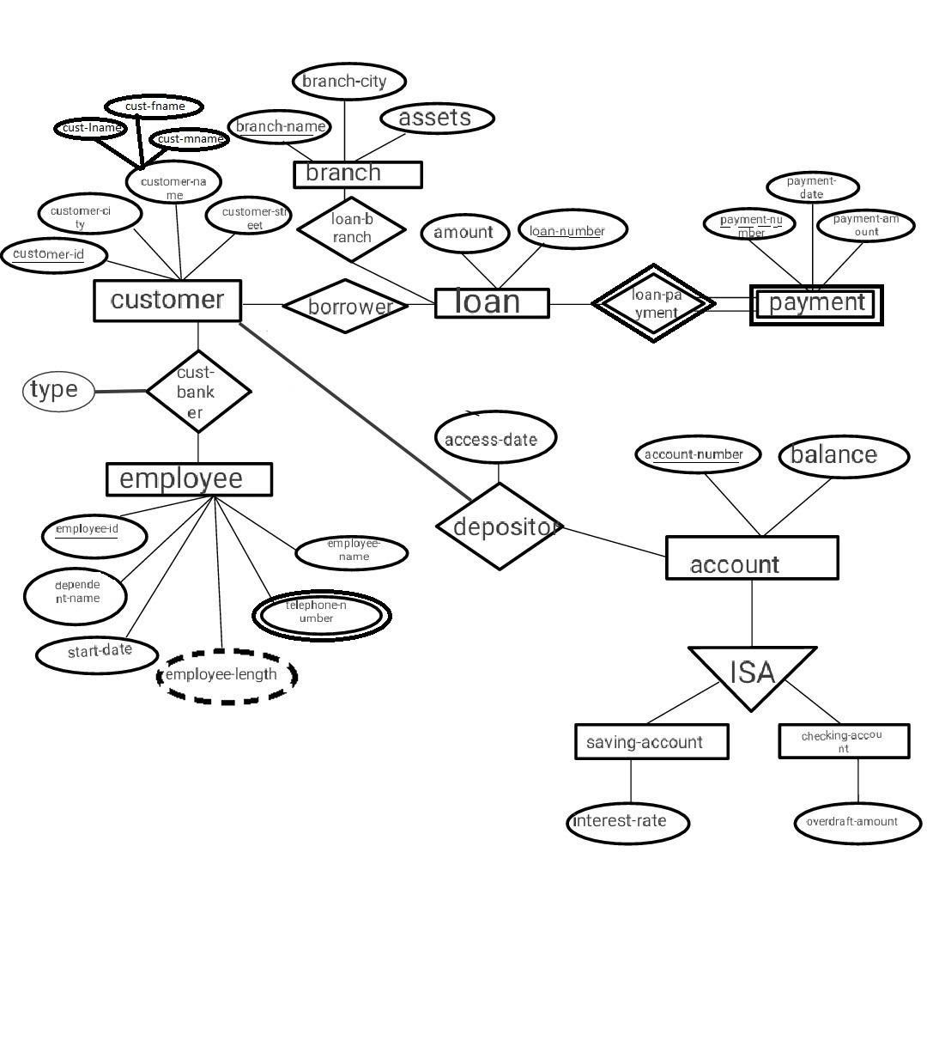

**Steps to convert ER/EER to Relational Tables:**

Step 1: Converting simple entity to Relational database

Customer is as simple entity

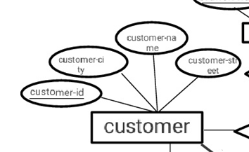

Customer

(customer_id, customer_name, customer_street, customer_city)

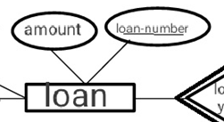

Loan

(amount, loan-number)

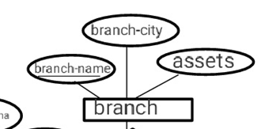

Branch

(branch-name, branch-city, assets)

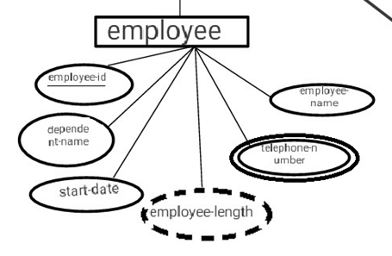

Employee

(employee-id, dependent-name, start-date, employee-name)

Step 2: Converting Composite attributes to relational tables.

Customer

(customer_id, customer_fname, customer_mname, customer_lname, customer_street, customer_city)

Step 3: Converting multivalued attributes to relational table.

employee

(employee_id, employee_name, Department_name, start_date): primary key

Telephone-number

(employee_id, Telephone _number): composite key (super key)

Step 4: Converting weak entity to relational table.

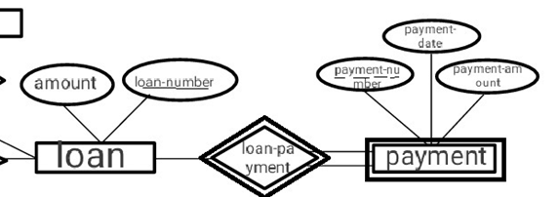

loan

(loan-number, amount)

Payment

(payment_number, loan_number, payment_date, payment_amount) Foreign key: Loan_number

Step 5: Mapping Cardinalities (Relationship 1:M or M:1).

1:M

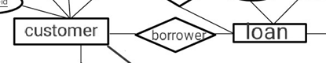https://docs.google.com/drawings/u/0/d/sFr1-bt1xHLB4UW4_LOHjtw/image?w=21&h=28&rev=1&ac=1&parent=1ocaCcid1re77FoavQDr5JChbpjQ0gCrPhttps://docs.google.com/drawings/u/0/d/sFwdmRbBLdud_YnmusyP-Gg/image?w=21&h=28&rev=1&ac=1&parent=1ocaCcid1re77FoavQDr5JChbpjQ0gCrP

Customer

(customer-id, customer-city, customer-name, customer-street)

Loan

(amount, loan-number)

Borrower

(customer-id, loan-number)

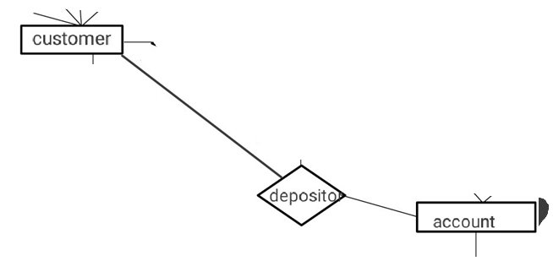https://docs.google.com/drawings/u/0/d/sUm0BUn_X_vMTIzjXtnFGqQ/image?w=21&h=28&rev=1&ac=1&parent=1ocaCcid1re77FoavQDr5JChbpjQ0gCrPhttps://docs.google.com/drawings/u/0/d/sCB2-bQ9hyaEIMgpbR4H6Eg/image?w=21&h=28&rev=1&ac=1&parent=1ocaCcid1re77FoavQDr5JChbpjQ0gCrP

Customer

(customer-id, customer-city, customer-name, customer-street)

Account

(account-number, balance)

Depositor

(account-number, customer-id)

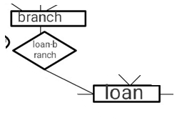https://docs.google.com/drawings/u/0/d/sBRjYYa1rm_ptXysXEdkD-g/image?w=21&h=28&rev=1&ac=1&parent=1ocaCcid1re77FoavQDr5JChbpjQ0gCrPhttps://docs.google.com/drawings/u/0/d/sihTRQXu0XyrkI-EfacO-Lw/image?w=21&h=28&rev=1&ac=1&parent=1ocaCcid1re77FoavQDr5JChbpjQ0gCrP

Branch

(branch-name, branch-city, assets)

Loan

(amount, loan-number)

Loan-branch

(loan-number, branch-name)

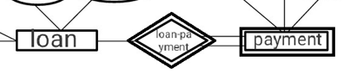https://docs.google.com/drawings/u/0/d/sjqbX2XKz7tEfk_DNYJa7DA/image?w=21&h=28&rev=1&ac=1&parent=1ocaCcid1re77FoavQDr5JChbpjQ0gCrPhttps://docs.google.com/drawings/u/0/d/shsmcNxl3JoNoobJbtcNGMA/image?w=21&h=28&rev=1&ac=1&parent=1ocaCcid1re77FoavQDr5JChbpjQ0gCrP

Loan

(amount, loan-number)

Payment

(payment-number, loan-number, payment-date, payment-amount)

Loan-payment

(payment-number, loan-number)

Step 6: Mapping Cardinalities (Relationship 1:1).

Null

Step 7: Mapping Cardinalities (Relationship M: N).

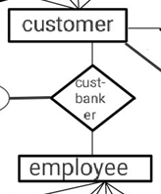https://docs.google.com/drawings/u/0/d/sG-hconsyYhp2glUXtXgBsg/image?w=21&h=28&rev=1&ac=1&parent=1ocaCcid1re77FoavQDr5JChbpjQ0gCrPhttps://docs.google.com/drawings/u/0/d/sVBHgqEZBFyc_20-DNRbNpQ/image?w=21&h=28&rev=1&ac=1&parent=1ocaCcid1re77FoavQDr5JChbpjQ0gCrP

Customer

(customer-id, employee-id, customer-city, customer-name, customer-street) employee-id: FK

Employee

(employee-id, customer-id, dependent-name, start-date, employee-name) customer-id: FK

Customer-banker

(customer-id, employee-id)

Step 8: Mapping EER features:

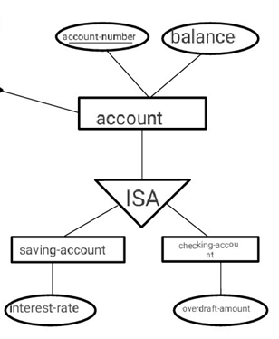

Account

(account-number, balance, interest-rate, overdraft-amount)

Saving-account

(account-number, interest-rate)

Checking-account

(account-number, overdraft-amount)

**CONCLUSION :-**Mapped the ER/EER model into the Relational Schema Model stepwise with initially mapping the regular entities then their weak entities. Followed by mapping of relationship with Cardinalities like m: n, 1:m,1:1 etc. Also, the multivalued attributes were also mapped leading to final relational schema.